How to add questions to the exam

There are 5 types of questions and each has a specific format that should be entered

To add a question to the exam go to <host>/add_question (login if required)

The data is returned from the database to the jinja template is marked as safe so no escaping is done. Be careful with this.

What the form looks like:

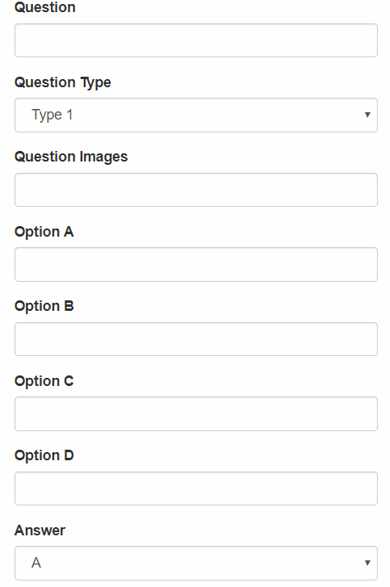

Type 1:

This is the simplest type of question

Simply fill in the question and the option (a to d) fields and select he appropriate correct answer and submit.

Type 2:

Arguably the hardest of the lot. The output will look something like this if done correctly:

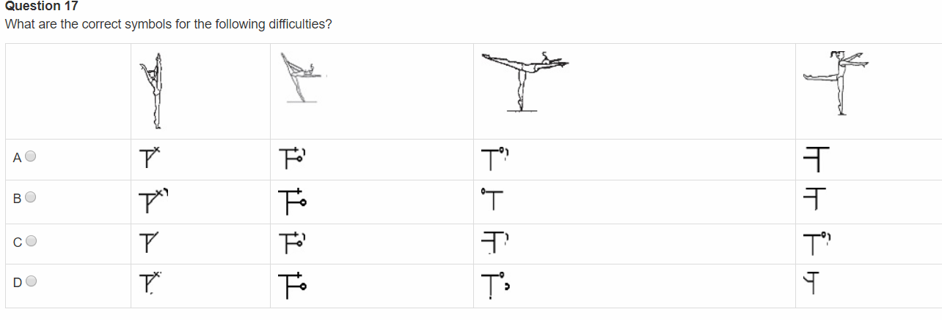

You have a question and then a table with images and answers as images in 4 columns

To make this happen:

Question field: Simple plain text with html tags if required

Type: 2

Question Images:

Will be saved as a json strong which can be converted to a dict later. An example of this is:

{"type":"image", "table_columns":"4", "path" : {"location":"static/q17","filename":["q17_q_1.jpg","q17_q_2.jpg","q17_q_3.jpg","q17_q_4.jpg"]}}

Type and table_columns are not actually used yet but the location and filename is and is important. Location is where the images are and the filename is a list (array) of images to display (the first item in the list will be at column row 2 because row one contains the question images and column is the option buttons

Type 3:

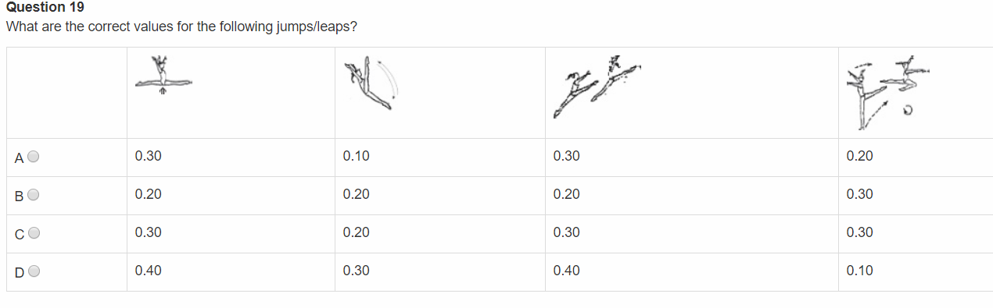

The question is plain text

The question image must be json and the format must be:

{"type":"image", "table_columns":"4", "path" : {"location":"static/q19","filename":["q19_q_1.jpg","q19_q_2.jpg","q19_q_3.jpg","q19_q_4.jpg"]}}

The options must be a json array and must be:

{"q_a":["0.30","0.10","0.30","0.20"]}

The identifier myst be “q_a”

Type 4:

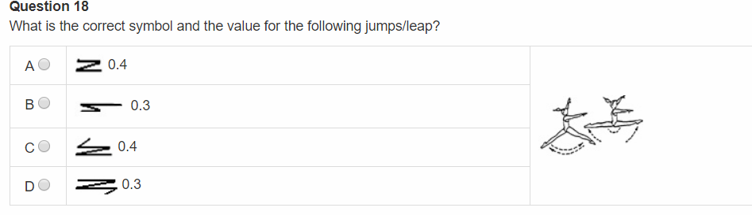

The question field is plain text

The question images field is in json and must be:

{"type":"image", "table_columns":"4", "location":"static/q18/q18_q_1.jpg"}

For the options place a json specifying the image location and the text to go with the image:

{"type":"image", "image_location":"static/q18/q18_a_1.jpg", "text":"0.4"}

Type 5:

This type has an image as part of the question (the reasoning behind setting “safe” for the data).

Examples of these are:

the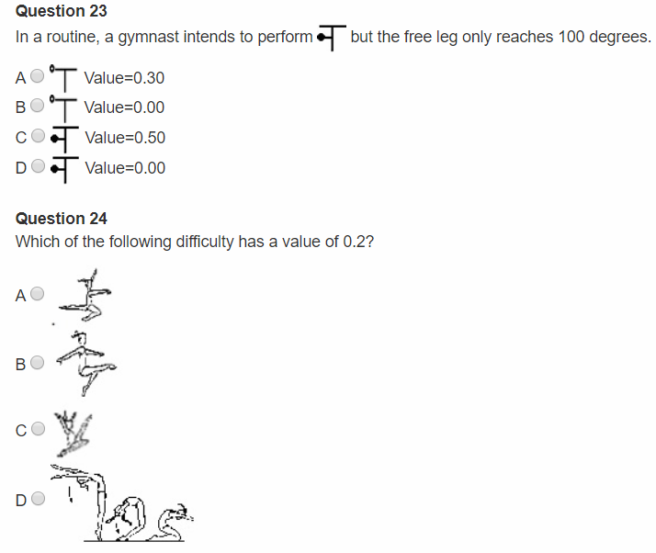

The question must be formatted as json and must have placeholders for where to inject the images:

{"question":"In a routine, a gymnast intends to perform <q_1> but the free leg only reaches 100 degrees. What is the symbol and value that the judge should record?","images":["static/q23/q23_q_1.jpg"]}

A maximum of 2 placeholders are catered for and must be specified as <q_1> and <q_2> and the images must be a list of where to find the images to replace position 0 will replace <q_1> and position 1 will replace <q_2>

The options (A to D) cateres for text and images and must be json in the form of

{"type":"image", "image_location":"static/q23/q23_a_1.jpg", "text":"Value=0.30"}

Omitting either image or text will omit it as part of the option value